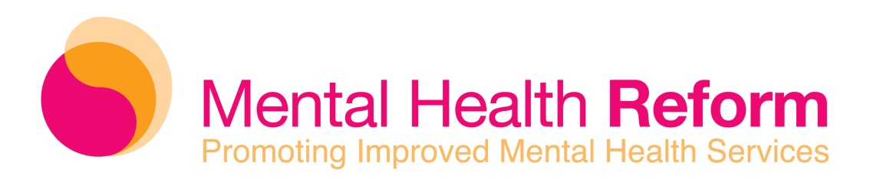
Why should my organisation join Mental Health Reform?
Our strengths is derived from our membership. Mental Health Reform relies on its members for their experience, skills and ideas. Our strong membership allows Mental Health Reform to campaign effectively for improved mental health services in Ireland. Because of our members, Mental Health Reform has established itself as the spearhead of the mental health reform movement in Ireland.
The benefits of membership include, but are not limited to:
- Opportunity to press for the implementation of A Vision for Change
- Participation in the movement for reform of the mental health services in Ireland
- Gain opportunities to lobby and campaign.
- Updates on political developments in mental health
- Notification of upcoming events relating to mental health reform
- Profile your work on www.mentalhealthreform.ie
- Research and media advice available on request
Who can become a member?
MHR offers both governing membership and associate membership to organisations who share our vision and values.
Governing membership is open to not-for-profit/non-governmental organisations with the exception of unions, professional associations, training and education bodies and non-governmental organisations who provide inpatient mental health services and/or approved centre(s).
Associate membership is open to all non-governmental organisations who are committed to the implementation of A Vision for Change, including unions, professional associations, training and education bodies and those who provide inpatient mental health services and/or approved centres. While associate Members do not participate in the Board structures of MHR and do not have voting rights at Annual General Meetings, their participation is an integral part of the movement to improve mental health services in Ireland.
Statutory bodies or organisations established by or within statutory bodies, local authorities, governmental agencies and state entities are not eligible for membership of MHR.

How can my organisation join?
You will find an application form below. Please fill this out and return it to Orla Barry at obarry@mentalhealthreform.ie. Applications go before the Board on a two monthly basis and may take up to three months before approval.
Cost of Membership
Governing membership fees depend on the income of your organisation.
Associate membership is €9 per months (€108 per annum).

Organisations with an income of:
€1m and over = €49 per month (€588 p.a.)
€700k - €999k = €39 per month (€468 p.a.)
€400k - €699k = €19 per month (€228 p.a.)
€100k - €399k = €9 per month (€108 p.a.)
Under €100k = €4 per month (€48 p.a.)

Associate membership = €9 per month

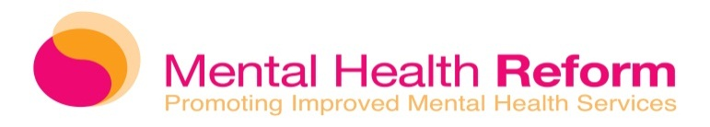

Application Form

Membership of Mental Health Reform
NAME of your organisation
ADDRESS

PHONE
EMAIL
WEBSITE

In case of membership, these details will feature on www.mentalhealthreform.ie.
Name of Director/CEO
Name of Contact Person
Brief Description of the Group

Date of Establishment
Legal Status
No. of Members
Annual Income

By signing this form, this organisation commits to support the values, vision and mission of Mental Health Reform.
Please indicate the type of membership you are applying for:
Governing Membership Associate Membership
Signature: Date:

