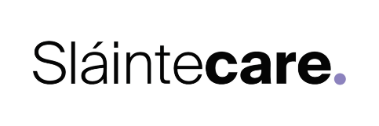
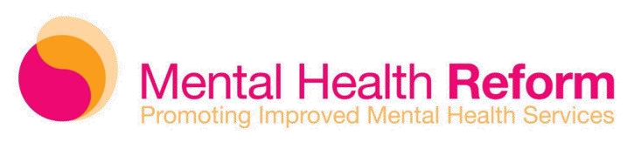

Evaluation of a Cultural Sensitivity Training Programme for HSE Community Mental Health Teams.
About Mental Health Reform
Mental Health Reform (MHR) is the leading national coalition on mental health in Ireland. We have 77 member organisations, representing a broad range of interests, housing, disability, children’s rights, human rights, ethnic minorities and many others. MHR provides a unified voice campaigning for progressive reform of mental health services and supports in Ireland.
Aim of the Evaluation
MHR is seeking tenders to design and conduct a process and outcome evaluation of a Cultural Competency Education Programme for HSE Community Mental Health services and staff. Findings from the evaluation will inform the development of a toolkit for the implementation of cultural competency education for all HSE Community Mental Health services staff.
Project overview
This Sláintecare Integration project aims to adapt, pilot and evaluate a cultural competency education programme to enhance cultural competency of staff working in HSE Community Mental Health services. The project’s goal is to ensure that people from ethnic minority communities receive mental health services and supports that adequately meet their needs in a culturally competent and appropriate way.
The project is being implement with the Cabra CMHT and the programme has been developed by Diversity Cymru (a Welsh Charity which specialises in delivering well-supported cultural competency education for UK health services staff)
Context
A Vision for Change and Ireland’s new national mental health policy framework, Sharing the Vision, both recognise that culturally appropriate services are important for service users from diverse cultural and ethnic minority communities. These strategies recommend that:
“Mental Health Services should be provided in a culturally sensitive manner. Training should be made available for mental health professionals in this regard and mental health services should be resourced to provide services to other ethnic groups including provision for interpreters (Recommendation 4.8)”
“The HSE should maximise the delivery of diverse and culturally competent mental health supports throughout all services (Recommendation 61) “
However there has been little implementation of these recommendations to date.
Between October 2012 and April 2013, MHR convened a series of consultation meetings with representatives from black and minority ethnic (BME) community organisations. Key issues identified in these meetings included:
- current policy documents were weak on policy about cultural sensitivity

- the need to introduce cultural competency training for mental health services staff to help ensure that ethnic minority mental health service users have access to culturally sensitive services that adequately meet their needs
In response to these issues, and with support of the Mental Health Commission, MHR developed and published guidelines for mental health services and staff on working with people from ethnic minority communities. Building on the guidelines published in 2016, the project will adapt and pilot a cultural competency education programme for HSE Community Mental Health services and staff.
The successful applicant will independently evaluate both the process and outcomes of the piloting of this cultural competency programme.
Evaluation Methodology
The design of the evaluation is to be proposed by applicants as part of their tender submission. However, MHR expect that data will be gathered from key stakeholders (trainers and Community Mental Health Team members) and that aspects of a pre-training survey of Community Mental Health Team members (conducted by MHR) will be incorporated to facilitate pre-post training comparisons.
Deliverable
A high quality report of publishable standard outlining the findings of a process and outcome evaluation of Diverse Cymru’s Cultural Competency Education Programme adapted for use in Ireland is the deliverable. Note that the successful applicant(s) will be required to submit at least two drafts of the report in advance of final submission, and edit according to feedback from the project Steering Group.
Indicative Timeframe and Budget
This evaluation will take place over a three month period, expected to begin no later than the 22nd of March 2021. The maximum budget for this evaluation is €15,000. MHR will not automatically select the most economically attractive tender, but will consider the breakdown of tasks and time allocation in its selection process.
Requirements
Successful applicants should have the following:
- Postgraduate degree in a relevant discipline;
- Knowledge of mental health services and policies in the Irish context;
- Experience using a range of research methods, including evaluation research methods, desk-based research and qualitative and quantitative research methods;
- Knowledge and experience of working with multi-agency steering groups and stakeholders;
- Experience in the maintenance of detailed, accurate and fully evidenced time-keeping records;
- Experience in producing high quality evaluation research reports to publishable standard;
- Exceptional attention to detail and ability to adhere to strict reporting and budgetary requirements.
Tender Process
Tendering organisations or individuals must submit a tender document. Each tender should use the following format:
- A description of the proposed methodology to be used to carry out this research;
- A detailed breakdown of costs, a project resource plan and timeline with respect to each element of the proposed work
- Details of previous experience in using relevant methodologies;
- A profile or CV of the organisation or individual making the proposal;
- Samples of previous relevant work and contact details of clients
Assessment of Tender
Each tender received will be assessed on the basis of:
- Demonstrated knowledge and understanding of the brief 10%
- Previous relevant experience 40%
- Proposed outline of research and methodology with timelines 40%
- Price 10%

To note: Additional information may be sought at the assessment phase. Before awarding the evaluation, a short listed number of the most competitive tenders may be invited for further discussions/interview on their proposals.
MHR shall not be liable for any costs and/or expenses incurred in respect of the preparation of the submission of any tender documents or associated material.
The timeline for projects is indicative.
Further detailed information on the projects may be sought from MHR in advance of submission of tender.
Tenders should be submitted by e-mail to pofeich@mentalhealthreform.ie

CLOSING DATE: 5pm on Monday the 8th of March, 2021.

Department of Health and Children (2006). A Vision for Change: Report of the Expert Group on Mental Health Policy. Dublin: The Stationery Office, p.41.
Department of Health and Children (2020). Sharing the Vision
Mental Health Reform (2014). Ethnic Minorities and Mental Health: A position paper. Dublin: MHR.
Mental Health Reform (2016). Ethnic Minorities in Mental Health: guidelines for mental health services and staff on working with people from ethnic minority communities. Dublin: MHR.

